DAYTON NATIONAL CEMETERY
GRAVE DECORATING CEREMONY
FOR
MEMORIAL DAY

SATURDAY
MAY 25, 2019
9:30 A.M.
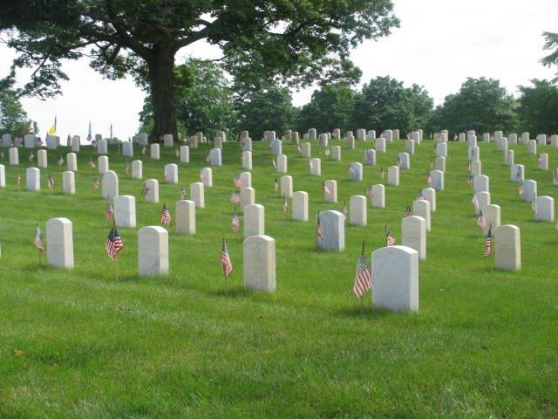
The Flag of the United States, popularly called the American flag is the official national flag of the United States. It consists of thirteen horizontal stripes, 7 red alternating with 6 white, and in the upper corner near the staff, a rectangular blue field, or canton, containing 50 five-pointed white stars. The stripes symbolize the thirteen colonies that originally constituted the United States of America. The stars represent the 50 states of the Union. In the language of the Continental Congress, which defined the symbolic meanings of the colors red, white, and blue, as used in the flag. “White signifies Purity and Innocence; Red, Hardiness and Valor; and Blue, Vigilance, Perseverance and Justice.” Because of its stars, stripes, and colors, the American flag is frequently called the Star-Spangled Banner, the Stars and Stripes, or the Red, White, and Blue. Another popular, patriotic designation, Old Glory, is of uncertain origin.

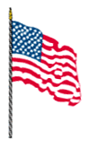
Saturday May 25, 2019

SPECIAL THANKS TO THE OHIO AMERICAN
LEGION FOR ANNUALLY SPONSORING THE GRAVE
DECORATING PROGRAM AT THE DAYTON
NATIONAL CEMETERY

Dayton National Cemetery gratefully acknowledges the participants in this Memorial Day Program. It is a special
HONOR to salute the Nation’s men and women who have made the ultimate sacrifice for our country:

- THE OHIO STATE HIGHWAY PATROL AUXILIARY
- BOY SCOUTS of AMERICA, MIAMI VALLEY COUNCIL
- GIRL SCOUTS of WESTERN OHIO
- CHAPLAIN SERVICES, DAYTON VA MEDICAL CENTER
- AMERICAN LEGION DEPARTMENT OF OHIO

The Grave Decorating Pin is awarded by the American Legion
to each participating scout as a THANK YOU and a symbol
of a job well done.

PLEASE ASSEMBLE AT THE SOLDIER’S MONUMENT

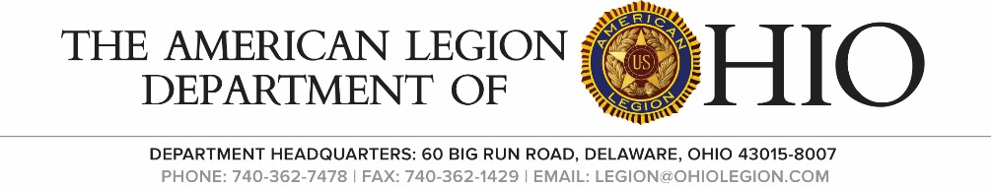
Welcome Douglas Ledbetter, Director
Dayton National Cemetery

Invocation Kenneth D. Boyd
VA Chaplain’s Services

Pledge of Allegiance Douglas Ledbetter

Introduction of Melissa Fowle,
Dignitaries Asst Sgt-At-Arms
Ohio American Legion

Address Robert Schmitt
State Commander,
Ohio American Legion

Remarks Kathy Heichel, President American Legion Auxiliary

Remarks Bernie Kessler, State
Commander, Sons of the American Legion

Presentation of Robert Schmitt
Grave Decorating
Pins

Benediction Chaplain Kenneth D. Boyd

Memorial Salute/Taps Dayton National Cemetery
Honor Squad

Instruction and Grave Douglas Ledbetter
Decorating

